Mimics to develop stl from CT dicom file

* File -> new project wizard
* Load dicom data
* Threshold (button on the top bar) 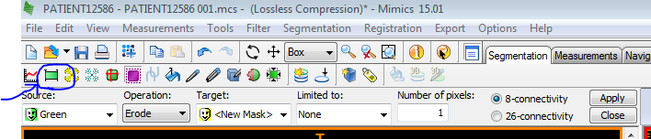
  + Threshold high ~900-3000 so just the part you’re interested in is highlighted (not any residuals). The mask should look like: 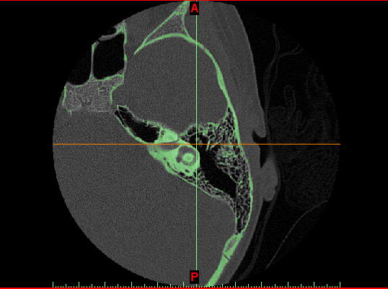
* Right click on the mask on the right bar -> Morphology Operations

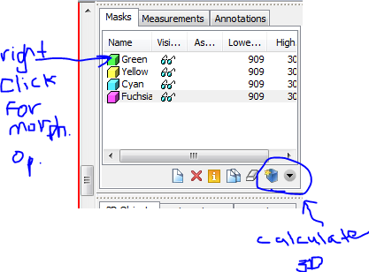

* + Ensure your mask is selected
  + Dilate: select number of pixels – dilates the thresholded region
  + Erode: select number of pixels – erodes parts of the region
  + On the right bar -> calculate 3D model
* Now you have a smooth model but it is missing information because of the dilate
* Edit mask:

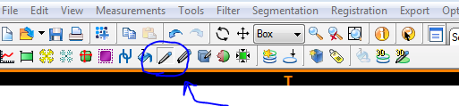

* + Select threshold
    - High range to recover air pockets
    - Low range (~2-3000) to recover structures that were hidden

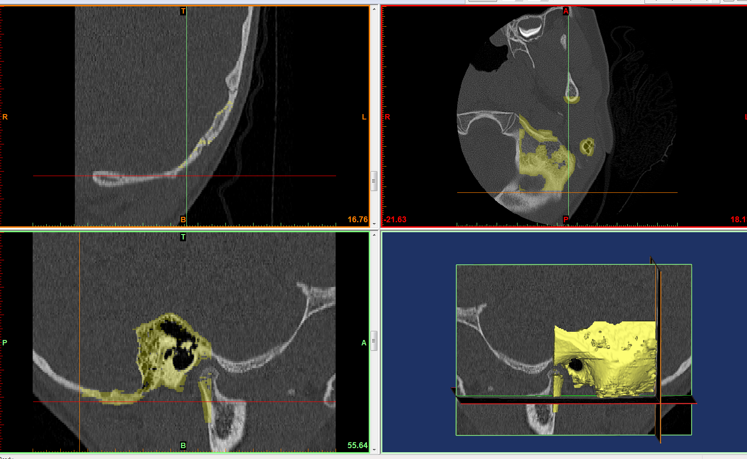

Bottom left shows the ear canal on the scan , bottom right shows the ear canal

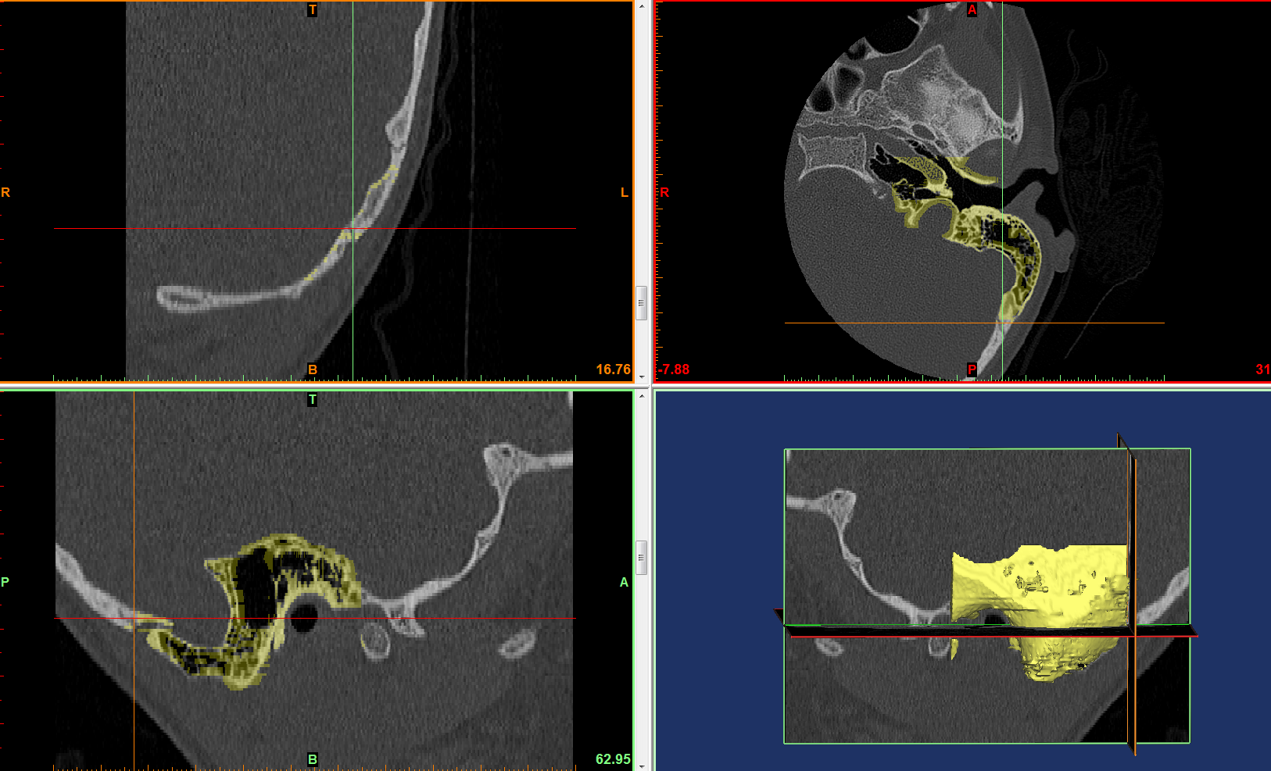

Arrows are pointing to the ear canal – goal is to use the edit mask tool to paint and select the regions with desired threshold

Only are worried about the ear canal as that is where the endoscope and instruments will go through

3D printing of ear model:

V-1 16-Nov-2016:

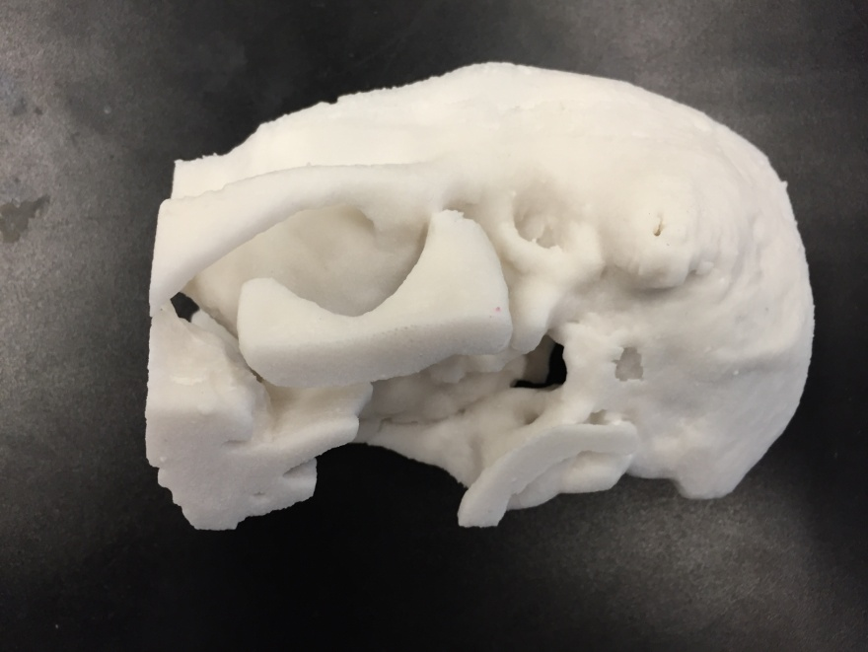

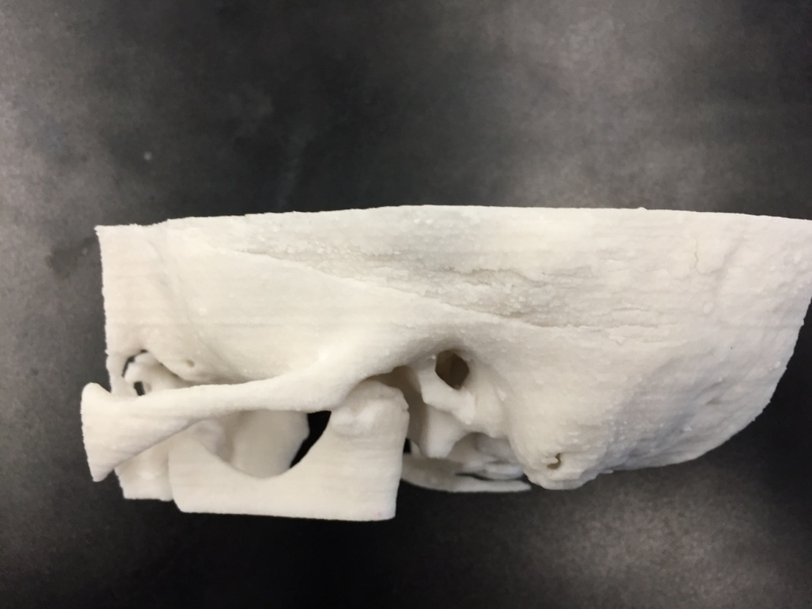

Feedback from Dr. James: Features were blurry – ossicles not visible, usable but not accurate

V-2 22-Nov-2016:

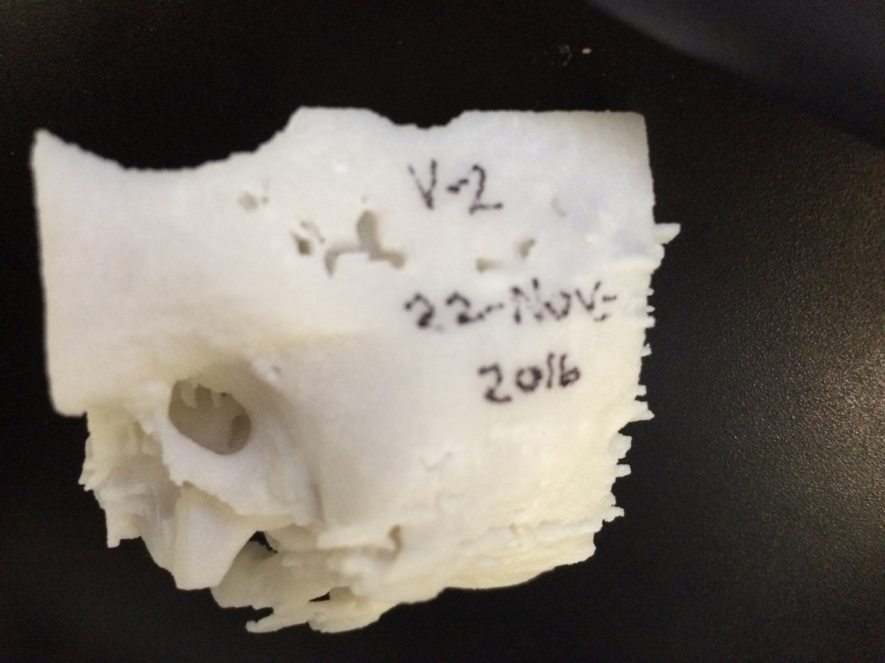

This one showed enough resolution for the hearing bones

Will test with endoscope

Good enough resolution

Keep the wall on top with holes in it because it allows us to see if the instruments are reaching areas from outside

The bone there is paper-thin anyway

Literature Search on Temporal Bone Models:

* 3D printed ABS temporal bone model

Virtual Model:

Integrating anatomy, tool, endoscope

Feb-2017: Took slices of model but it is hard to orient because need a reference (ie. Ossicles)

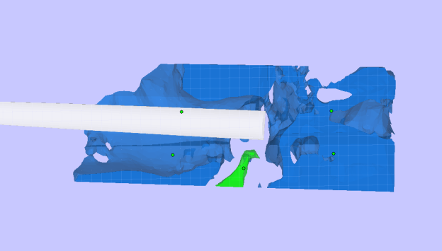

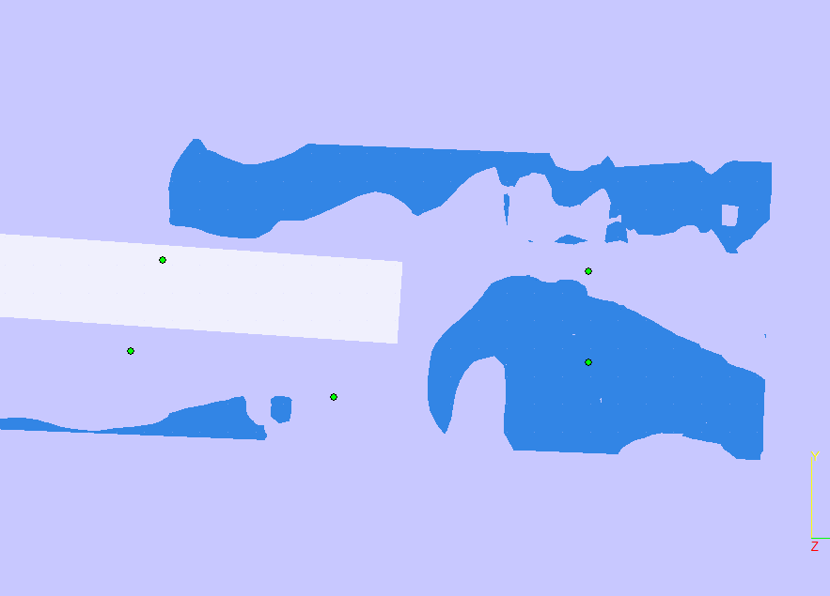

instruments should reach areas that of endoscope`s field of view.

“comparison of middle ear visualization with endoscopy and microscopy” (1)

* Built a 3D model of the ear space using VTK-based interactive segmentation editing software developed in the lab
* 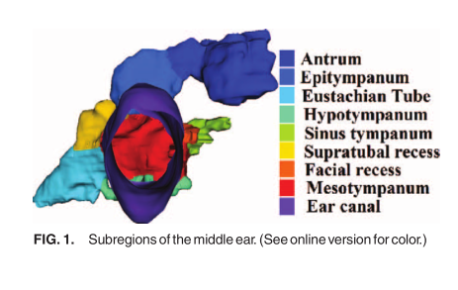
* Identify the 3D region defining the volume of space reachable by scope lens and range of angles at which scope could be oriented

Motivation for creating 3D models:

* Used to help surgeons in training (residents and fellows) learn techniques and can reproduce anatomy that may be tricky to help increase their skill, and handle difficult cases
* Cheaper way to practice than using cadaver, even though it can’t pick up soft tissue, it gives the bony anatomy and that would be useful to practice reaching places without having to drill, etc.
* Cheap way to test instruments and figure out what instruments would be good to perform the procedure in that patient (patient-specific surgical plan)
* Helpful to design new instruments’ geometry and size and visualize how the endoscope and instrument can move through anatomy

Creating temporal bone model: (2) – reference gives the steps I follow to create a model from CT scans

* CT scan -> threshold intensity levels are unique for each patient to isolate bone -> post processing of model consists of a 3D surface mesh -> smooth using Gaussian filter with std dev of 0.8mm and max approximation error of 0.03mm, optimal balance between a smooth surface and high enough resolution
* This paper also selected ossicles using manual segmentation (human judgement) because CT scan quality not high enough for automatic segmentation
* Rates the models by commenting on whether certain important structures are visible or not

(3) used mimics to create STL of bony anatomy + soft tissue structures -> printed on printer -> asked otolaryngologists to fill out a likert scale on how accurate the models were to real anatomy

14-Feb-2017:

* Modeling the air space – used mimics at negative threshold value and made a model for the air space surrounding superior region of malleus
* Will do the same for sinus tympani in another model
* Then make a model of just the air space

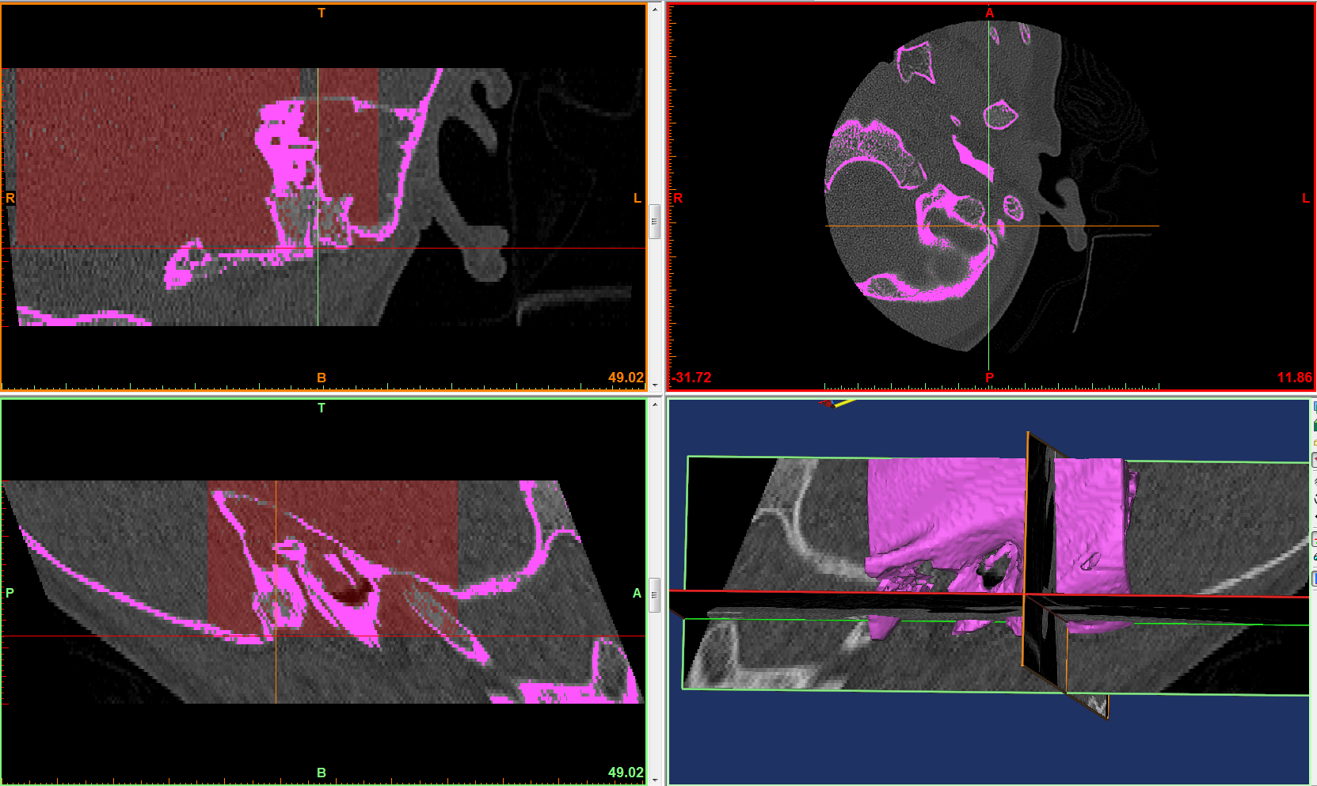 fuschia is a temporal bone mask made into the 3d model

Red is a negative threshold mask for soft tissue and air so use edit mask with a threshold paintbrush to deselect all the red except for inside the ear canal to get the following:

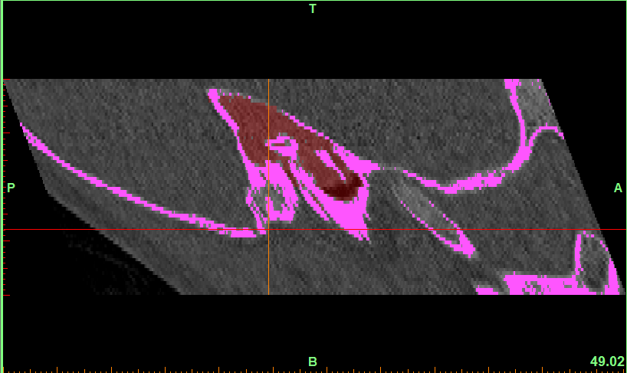

many softwares were investigated for this method.

rejected analyze because it didn’t provide a smooth surface rendereing

therefore used fusion 360

08-Mar-2017:

cropped patient 1720 model at this axial section that shows the antrum but not the ear canal:

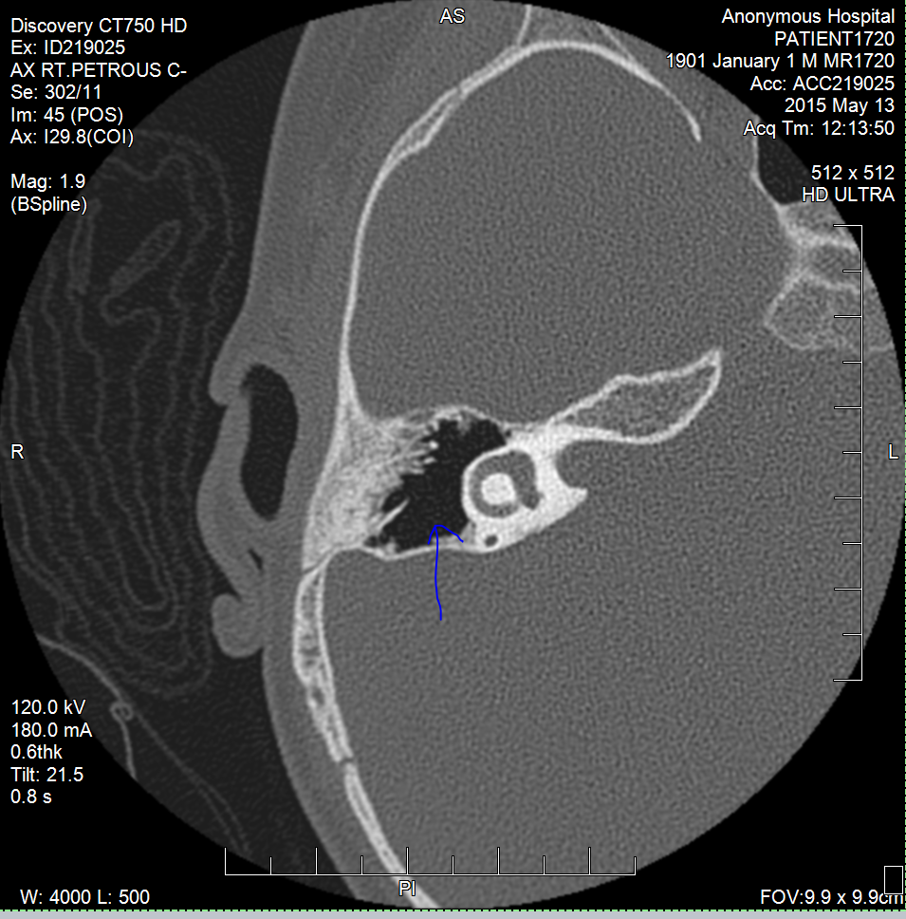

want to show if current instruments can reach this area in antrum beside semi-circular canal which usually prevents instruments from reaching up to the edges of the antrum here

Mimics: cropped the mask-generated STL so that it is exactly cropped axially: (files = /Users/arushriswarup/Documents/GitHub/Graduate-School/3D Models/anatomy stls/patient1720)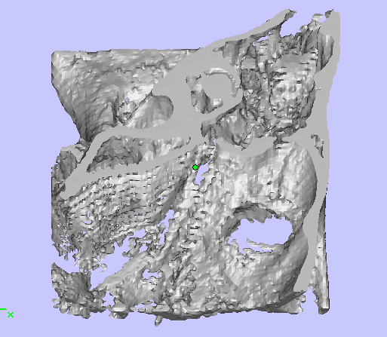 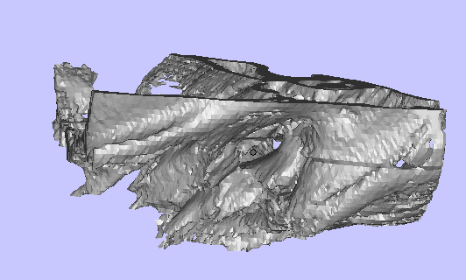

Imported into magics to smooth the edges and crop out the unnecessary noise, while preserving anatomy in ear canal and antrum’s superior edge

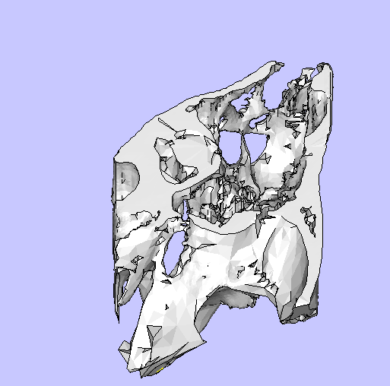 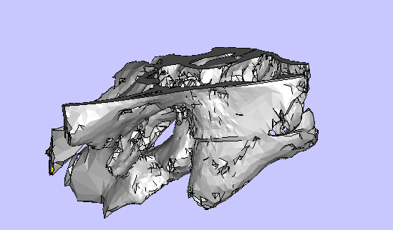

then went on meshlab to reduce the number of faces and smooth so that it can imported into solidworks where it can be easily integrated with the endoscope and instrument.

Integrated a reduced face version of the anatomy with endoscope and wristed instrument

But there are holes in the mastoid and other parts of bone that shouldn’t be there, so use magics to fill out the holes:

* Marking -> mark polygon -> outline the hole -> delete (+fn on mac)
* Fixing -> holes -> create bridge (there are two layers (two planes)) and create bridges between the edges of the holes on both layers, ensure bridges don’t overlap, they need to be carefully placed -> follow advice -> automatic fixing -> update
* Diagnostics/normal -> fix and update
* Marking -> mark polygon -> Refine and smooth until it looks good

Mar/Apr 2017

Created virtual model with endoscope, panetti, new tool and cropped patient anatomy

Want to show nitinol double modified joint bending so followed tutorial: <https://www.youtube.com/watch?v=WyaPSE1u6kg>

20-Jun-2017

Rendering 3D temporal bone model of multiple patient CT scans to calculate the curvature of tool to reach a target point inside the middle ear

Mimics projects saved at: C:\Users\arushri swarup\Documents\3D models\CT scans_May 2017\A

Folders from A-K for different patient CT scans

Mimics **volume rendering**:

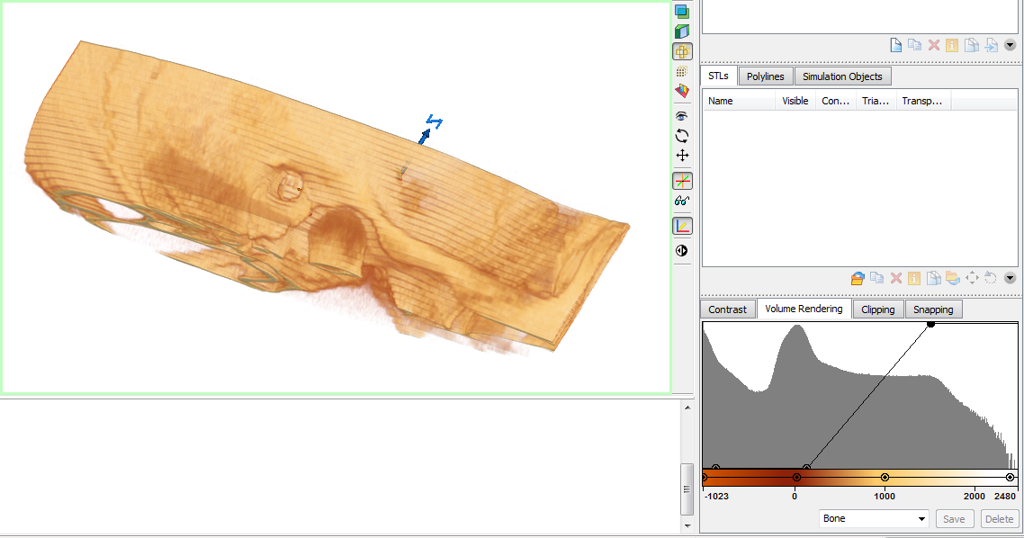

3-Matic

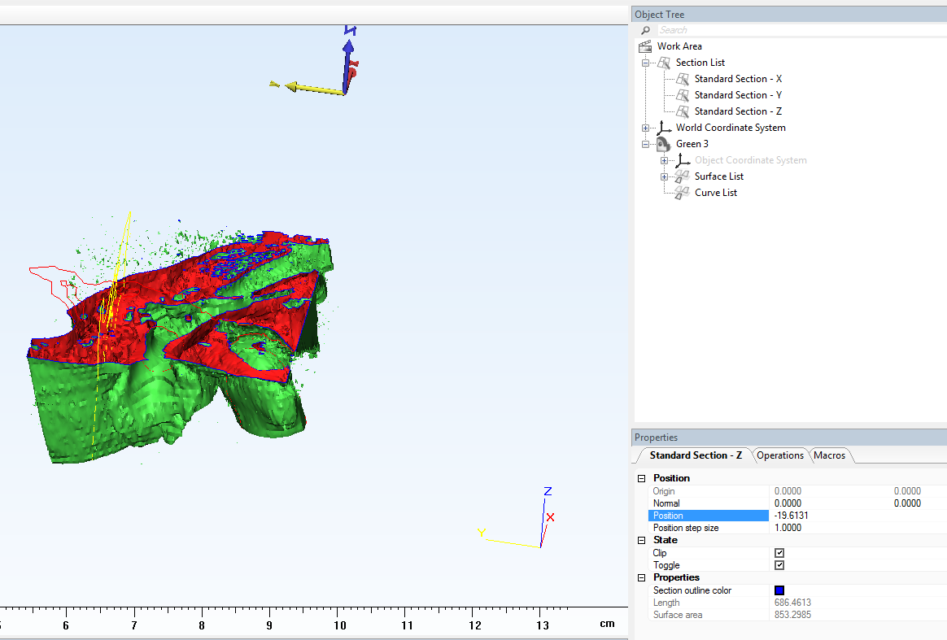

* Right click on Standard Section-Z and under the properties menu -> position -> can change position

21-Jun-2017

Mimics:

* load CT scan -> threshold for bone -> crop the mask -> erode (1 pixel, 8-connectivity) -> dilate (1 pixel, 8-connectivity), ensure the correct mask colour is selected as the source
* split the ossicles from the temporal bone model
  + duplicate mask
  + split mask feature
  + find the ossicles on the CT scan
  + paint over with split mask paintbrush

3-Matic:

* Export Mimics project to 3-Matic
* Duplicate model -> fix - Wrap – set parameters: gap closing distance = 0.25, smallest detail = 0.25 -> fix wizard
* Section the model to identify the target points to be reached by the bendable tool

1. Bennett ML, Zhang D, Labadie RF, Noble JH. Comparison of Middle Ear Visualization With Endoscopy and Microscopy. Otol Neurotol. 2016;37:362–6.

2. Cohen J, Reyes SA. Creation of a 3D printed temporal bone model from clinical CT data. Am J Otolaryngol - Head Neck Med Surg [Internet]. Elsevier Inc.; 2015;36(5):619–24. Available from: http://dx.doi.org/10.1016/j.amjoto.2015.02.012

3. Rose AS, Kimbell JS, Webster CE, Harrysson OLA, Formeister EJ, Buchman CA. Design of a 3D Model for Temporal Bone Surgical Simulation. 3342.